# **Solution**

## **Insert sample data into the Students table.**

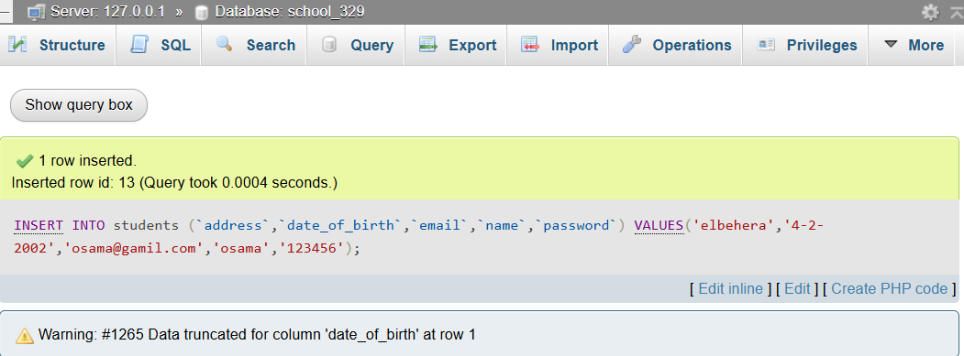

## **Insert sample data into the Instructors table**

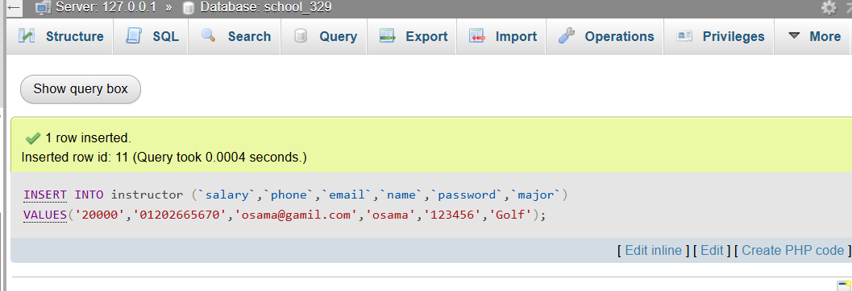

## **Update a student’s email address.**

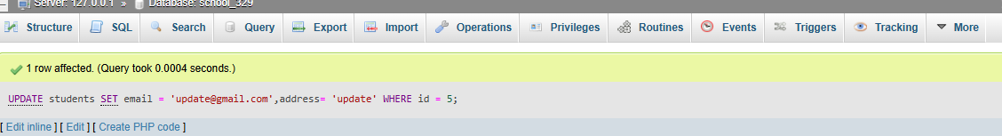

## 

## **Find the total number of students in the database..**

## **Screenshot 2025-04-23 222503Delete an enrollment record (remove a student from a course).**

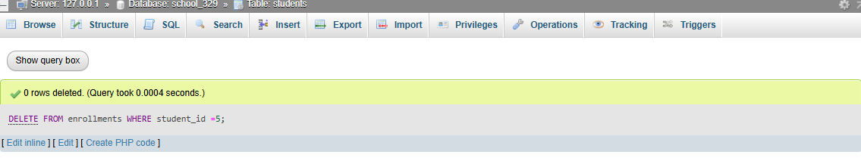

## **Enroll a student in a course by inserting data into the Enrollments table**

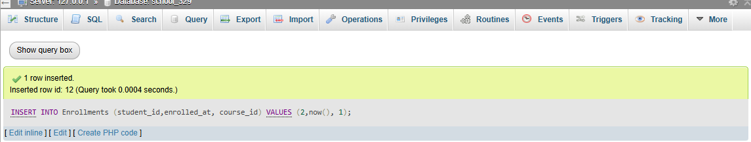

## **Insert sample data into the Courses table..**

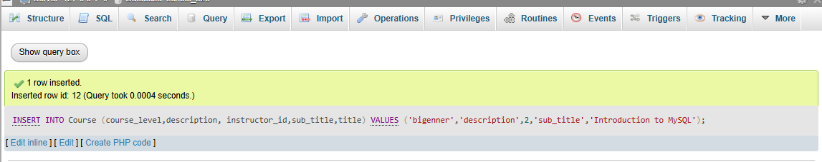

## **Retrieve all students enrolled in the Introduction to MySQL course.**

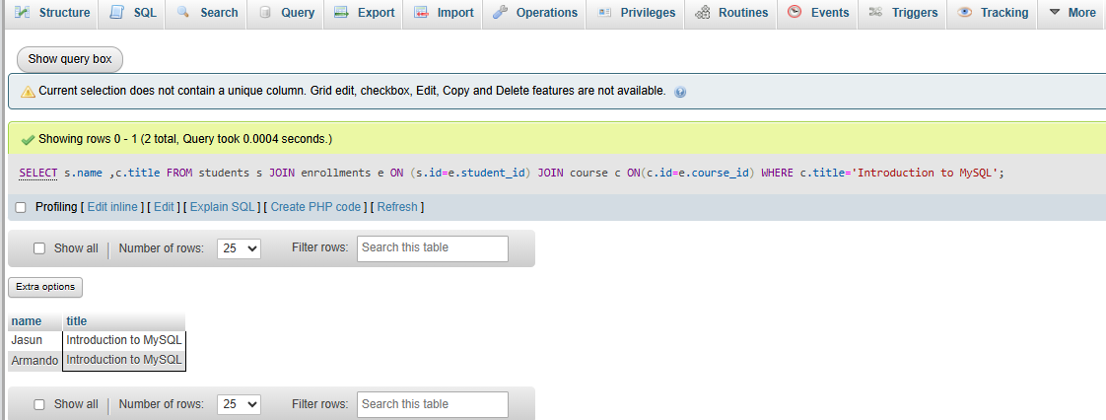

## **List all courses with the instructor’s name.**

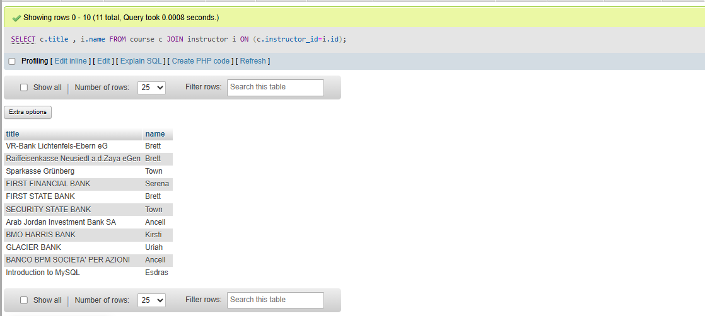

## 

## **Count how many students are enrolled in each course.**

## Screenshot 2025-04-23 235744

## **Retrieve the list of courses a specific student is enrolled in.**

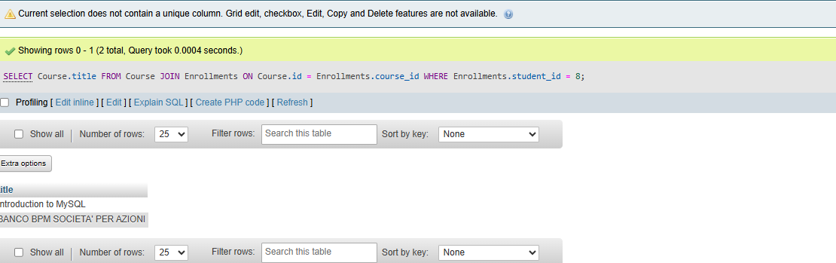

## 

## **Retrieve all instructors who have more than one course.**

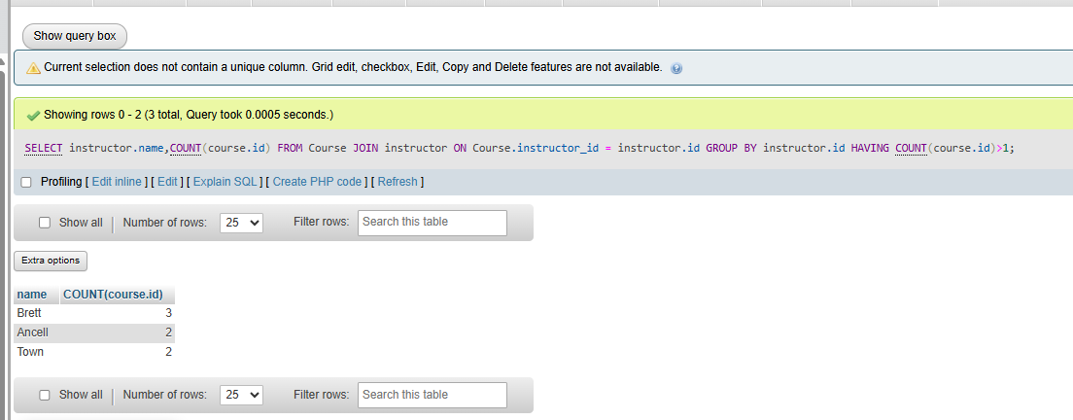

## **List all students who have never enrolled in any course.**

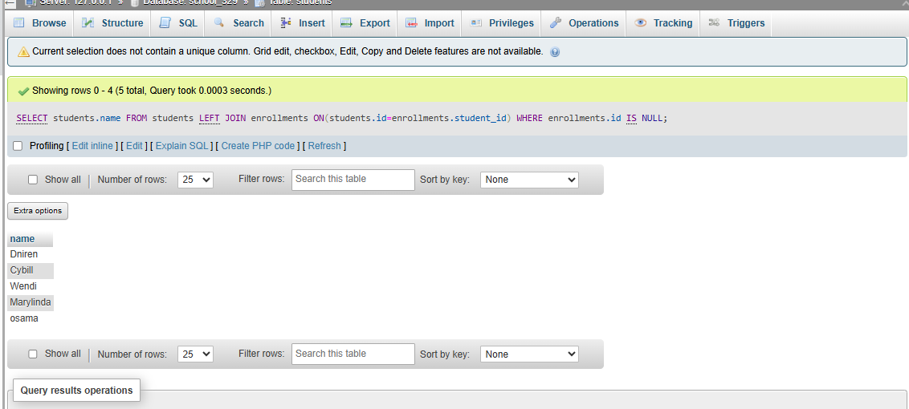

## 

## **Get the number of courses taught by each instructor.**

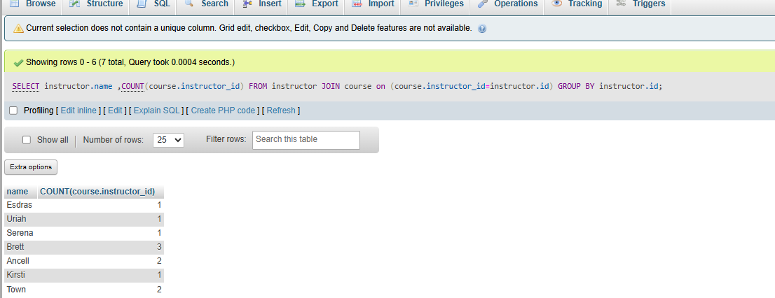

## **Find the average number of students per course.**

